IFB 299

Myles Wardell

n9735691

Personal Portfolio

Individual Assessment

**Sprint 1**

**CS Implementation**

Artefact 1: Initial Implantation of ASP.net

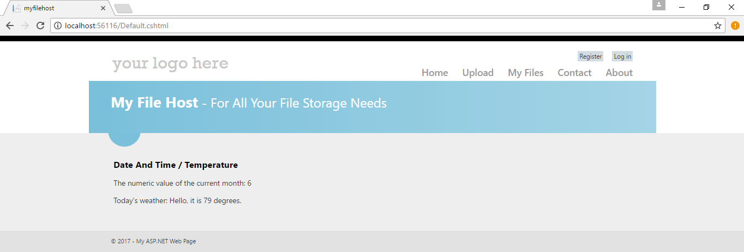

Description:

This project was the initial implantation of the myfilehost.netii.net website, this would be the title page where we would have offers on how much our service would cost

Artefact 2: Basic Upload Design

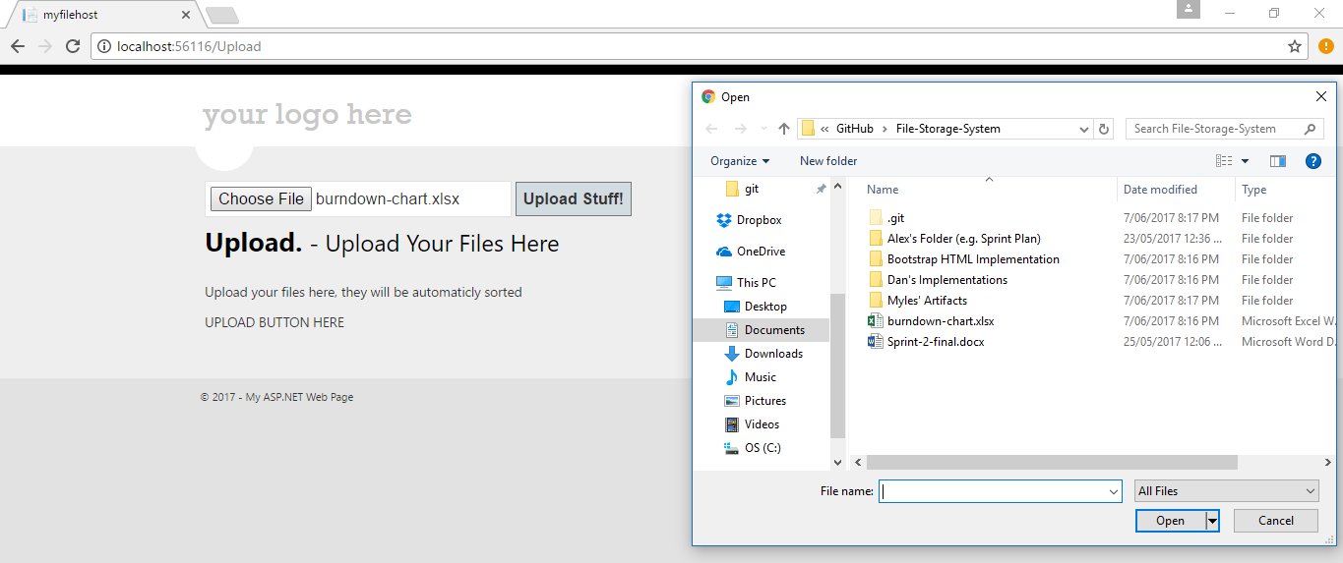

Description:

This artefact shows the beginning of a basic file upload system that would traverse system directories

Artefact 3: Limited Template of Displaying Files

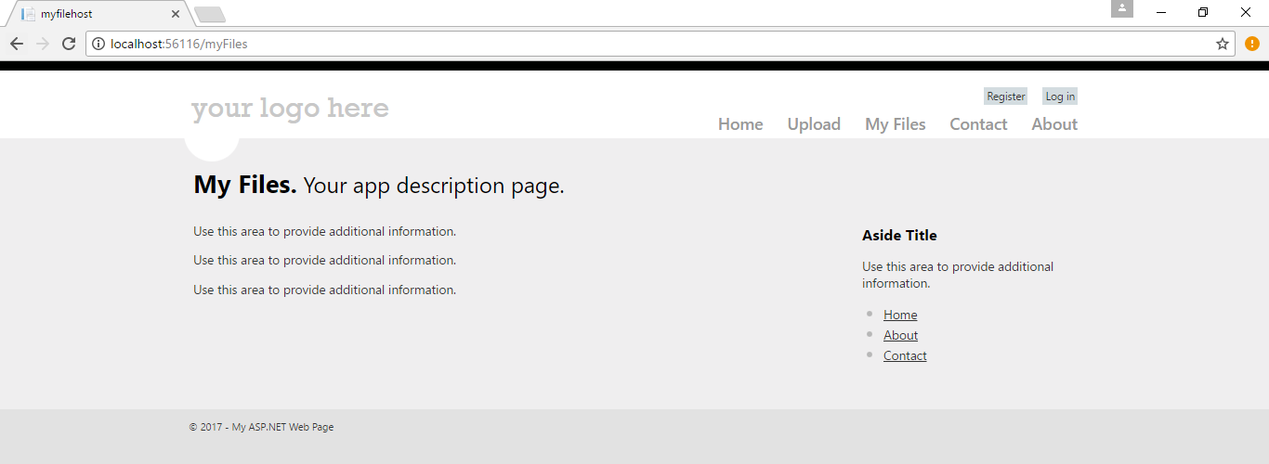

Description

This artefact shows the bare bones of the file display system

Reflection

I initially came up with the idea of implementing the file hosting service as a asp.net web program run on C# and HTML. We did this because none of us have any knowledge in JavaScript, CSS or PHP therefore I decided that building a program based on C# (a common language that we all new) would be a good idea. This ultimately failed due to the lack of knowledge on how to host the system online, the lack of knowledge on how to program features and edit style design (how different it was then just building a simple c# window application) and the lack of tutorials and suitable information online on how to us ASP.net.

**HTML Implementation**

Artefact 1: Home Page

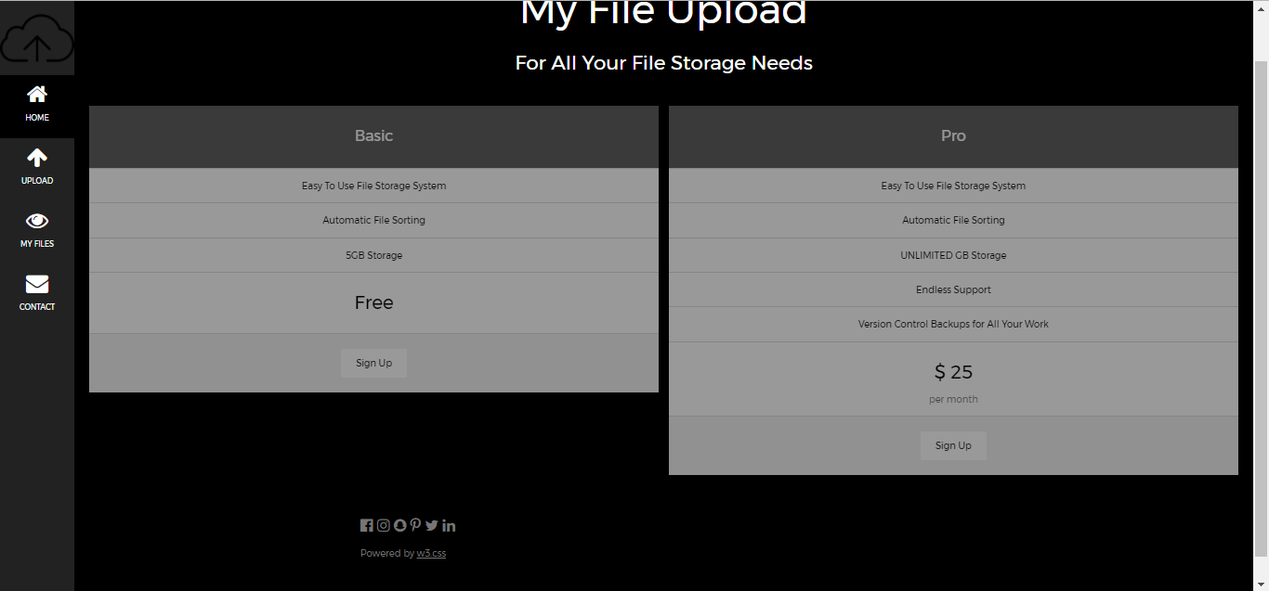

Description

This was the bare bones of our home page that was brought over from our CS implementation

Artefact 2: Upload

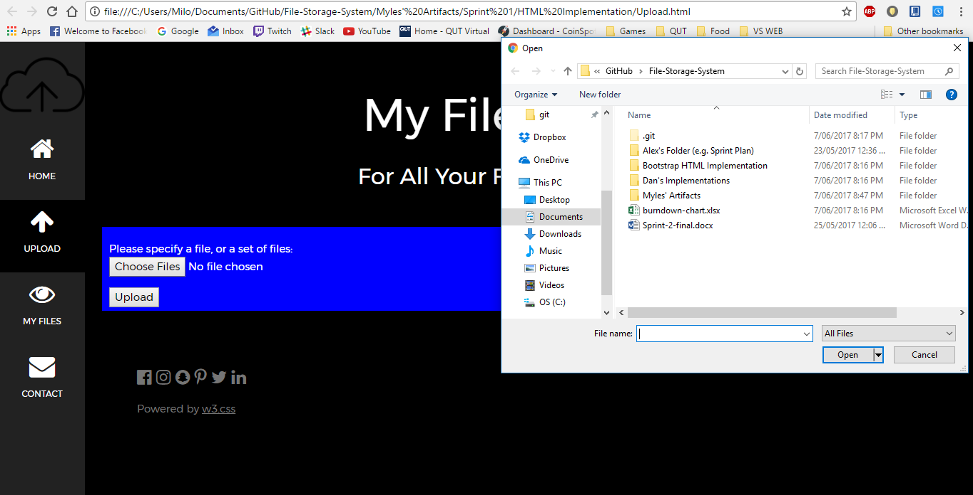

Description:

I coded and changed the template .html file and added the file directory JavaScript. Although I had access to the file link (using <input…) I did not code the initial upload.php file that was coded from a tutorial by Tyler Martin

Artefact 2: File Viewer

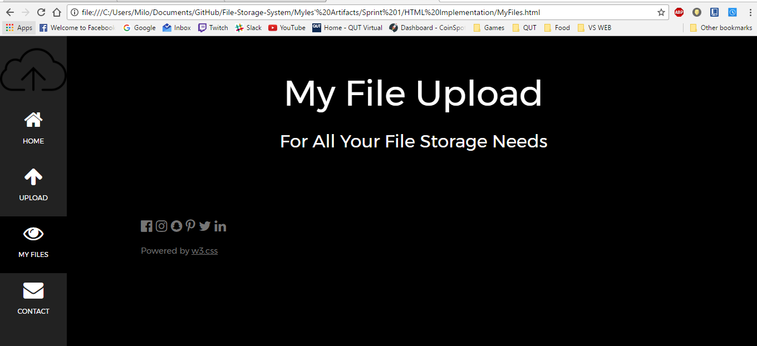

Description

This was a bare bone template of file viewing

Reflection

After I realised that ASP.net wasn’t working and was taking too much time to research and implement features I moved to more traditional web building looking up tutorials from w3 school to get a template for a new implementation of the web hosting service. This also ultimately didn’t work as the template that was chosen didn’t have the design I was looking for (see Dan’s Artefacts of rudimentary Google Sign in)

Side Note:

At this point we are halfway through Sprint 1 and I rush to get something together and get my team to pitch in some ideas

**Bootstrap Implantation**

Artefact 1: Home Page

**Sprint 2**

Artefact 1

Artefact 2

Artefact 3

Artefact 4